Raising attainment with Text Readers and Ceitidh

Ideally, we hope that all learners will learn to read, but unfortunately, some will always struggle either as a result of, for example, visual impairment, dyslexia, or learning difficulties. Slow or poor reading is a huge barrier to accessing the curriculum and learners who do have reading difficulties are at an enormous disadvantage in school.
Computer text readers, or text-to-speech, offers one way for these learners to overcome their difficulties with reading.
Computer readers can also be very helpful for students who are learning a second language, both to support reading and also to support the writing process.
This sheet summarises some of the main ways to support learners using computer text readers.
Supportive Practice | Your notes – which learners would benefit; what technologies will you use.
Improve access to the curriculum by reading:
- web sites;
- curriculum materials from staff;
- Textbooks from the Books for All Scotland Database.
Improve performance in literacy assessments and examinations by using a computer reader.
Improve writing by:
- proofreading with computer reader;
- supporting spelling with word banks;
- supporting spelling with word prediction.
Improve learning using interactive digital resources:
- Clicker 7.
Improve communication, for learners with communication support needs using voice output communication aids and software.

Technologies to support Literacy in Gaelic

Ceitidh, the Scottish Gaelic computer voice | Free from http://www.thescottishvoice.org.uk/home/
Computer text readers  See http://www.callscotland.org.uk/info+rmation/text-to-speech/  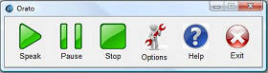  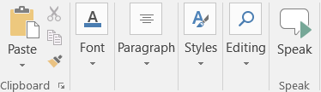 | - WordTalk, free  http://www.wordtalk.org.uk/  - NaturalReader 13, free http://www.callscotland.org.uk/common-assets/cm-files/files/naturalreader.exe  - Orato, free http://www.callscotland.org.uk/information/text-to-speech/orato/  - Ivona MiniReader, free  (No longer available but installed on many schoo computers already.)  - Microsoft Office Speak Button, free  http://www.callscotland.org.uk/blog/speak-text-in-microsoft-word-2010/  - Learning Tools for OneNote, free  https://www.onenote.com/learningtools
Penfriend XL  Word predictor, computer reader and spellchecker.  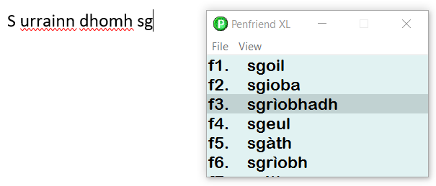 | - Penfriend XL, from £95 single, £400 primary, £600 secondary site http://www.penfriend.biz/pf-addit-lan.html  - Gaelic lexicons from http://www.penfriend.biz/download-lexicons.html
Clicker 7 literacy toolkit.  Word processor, mind-mapper, spellchecker, computer reader, word prediction, interactive activities. | - Clicker 7 £250 single; various licences available. http://www.cricksoft.com/uk/products/clicker/
Widgit Online with Dual Language  Create symbol flashcards, timetables, stories and a lot more. | - http://www.widgit.com/products/widgit-online/

