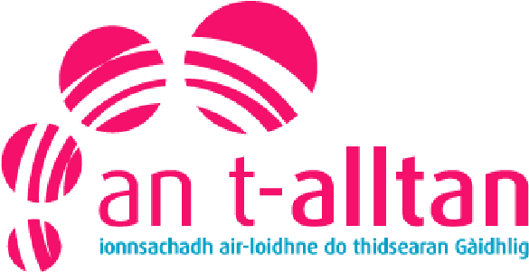

Cluich agus Ionnsachadh

Lisa NicDhòmhnaill

Seo taisbeanadh mu chluich agus ionnsachadh ann am Foghlam tro Mheadhan na Gàidhlig. Bidh sinn a’ coimhead air stiùireadh bho thaobh an riaghaltais cho math ri rannsachadh mu na dòighean obrach a tha air an cleachdadh ann an iomadach suidheachadh.

Seo ceanglaichean airson feadhainn de na goireasan:

Curraicealam airson Sàr-Mhathais
https://scotlandscurriculum.scot
https://ga.scotlandscurriculum.scot/

HGIOS
https://education.gov.scot/improvement/self-evaluation/hgios4/

Realising the Ambition
https://education.gov.scot/improvement/learning-resources/realising-the-ambition/

Pre-Birth to Three
https://education.gov.scot/nih/Documents/ELC/ELC2_PreBirthToThree/ELC2IntroPreBirthtoThree.pdf

UNCRC
https://www.unicef.org.uk/what-we-do/un-convention-child-rights/
https://cypcs.org.uk/rights/uncrc/
https://www.togetherscotland.org.uk/about-childrens-rights/monitoring-the-uncrc/incorporation-of-the-un-convention-on-the-rights-of-the-child/

WordsUp Highland
https://highlandliteracy.com/words-up-key-messages/

Play Scotland
https://www.playscotland.org

